Curriculum Vitae

Name: NGUYEN VAN VY
Place of born: Dien Hoa – Dien Ban – Quang Nam
BirthDay: 25/09/1991
Telephone: 01206147660
Email: nguyenvanvy09i2.cit@gmail.com
Facebook: https://www.facebook.com/vy.nguyenvan

Linkedin: https://vn.linkedin.com/in/vy-van-1a732898
Education
BACHELOR OF INFORMATION TECHNOsLOGY | SEP,2006 – SEP,2009 | THE COLLEGE INFORMATION TECHNOLOGY OF DA NANG
- Major: Information Technology. Minor: Software Engineering.
FROM 10/2012 – 7/2014| STUDENT AT THE UNIVERSITY OF DA NANG
- Major: Information Technology Minor: Software Engineering
- GPA:7.4
3/2015 - Today: Working at AsianTech Company , position: Developer Android.
Related Coursework:
- Linux Operating System, Network Programming.
- Language: Java, php, C, Android.
- Git, SVN.
- Web: Html, Jsp, Servlet, Ajax, Css, Struts 2.0, Hibernate, LifeRay portal.
- Database: MS Sql Server, MySQL, SQLite.
Project had work:
- Management of motorcycle parts and employee management.
  - Language: Java, Struts 2.0, JSP, Servlet,…
  - Database: MySQL.
  - Project period: 3 months.
  - Position: Developer.
- “Atone” is application Management personal expenses for monthly . This app have link to bank so user pay direct . This app have function notice new stores , new items to user.
  - Language: Android , Java.
  - Project period: 5 months.
  - Customer: Japan.
  - Position: Developer.
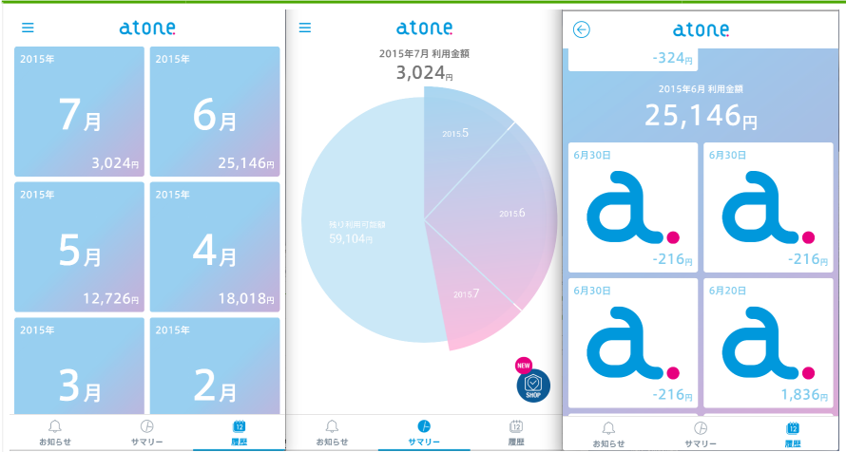
- “Seventeen” is application show clothing, costumes for schoolgirls 17 years old.
  - Language: Android , Java.
  - Project period: 6 months.
  - Customer: Japan.
  - Position: Developer.
- “Happy Hour” is system connect of shops. The shops show items. User can add shop or items of that in tab favorite. User can edit shop or information user and so on…. .
  - https://play.google.com/store/apps/details?id=hhapp.happyhours.android
  - Language: Android , Java.
  - Project period: 2 months.
  - Customer: Japan.
  - Position: Developer.
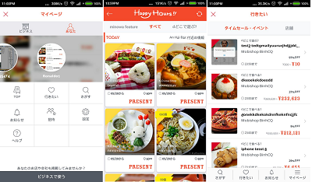
- Application Magazine.
  - Language: Android,Java, Php.
  - Database: SqlLite, MySQL.
  - Project period: 3 months
  - Customer: Europe.
  - Position: Developer.
- Building website “Information technology department” by PHP combined with MySql Database.
- Application “GeoApp”.
  - Language: Android(use SOAP),Java .
  - Database: SqlLite, client-server.
  - Project period: working.
  - Customer: Europe.
  - Position: Developer.
- “TryIt” is application watch video online.
  - https://play.google.com/store/apps/details?id=jp.co.trygroup.tryit.student
  - Language: Android,Java.
  - Project period: 2 weeks
  - Customer: Japan.
  - Position: Support.
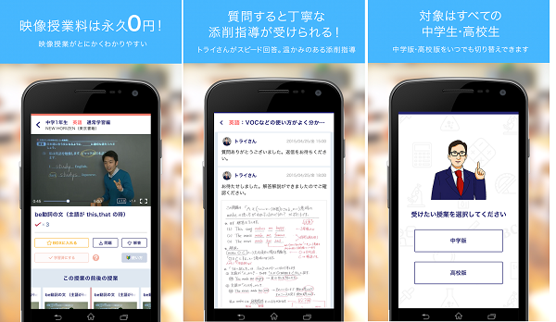

- “Flewer” is application social and search for Club, Dancer, DJ and so on. User can search club and dancer, and read post of clubs. Can be found club by Google Map. And User can chat realtime with dancer or club or DJ or ….
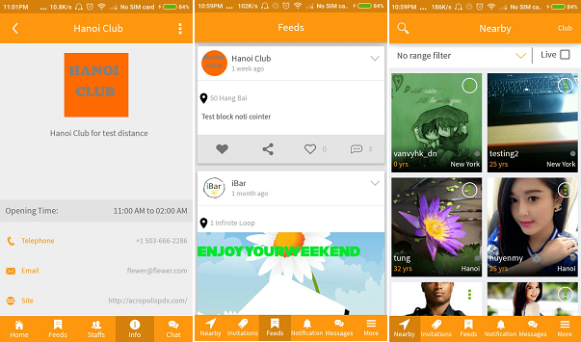
  - Not link app on store because have not release.
  - Language: Android, Java.
  - Project period: 4 months.
  - Customer: USA
  - Position: Coder and communicate directly with customer .
- “Seven Teen” is application show and introduce fashion model for seven teen years old. User can watch video introduce fashion model and can comment in community.
- https://play.google.com/store/apps/details?id=jp.co.shueisha.stchannel
- Language: Android,Java.
- Project period: 6months
- Customer: Japan.

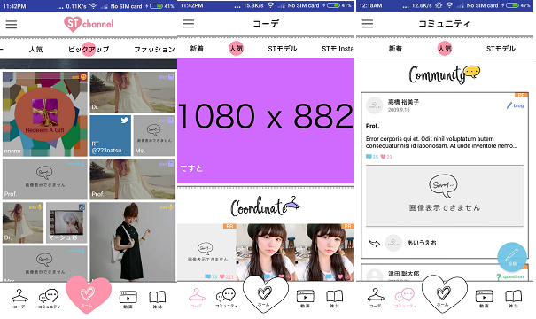
- “Epark” is application search store, hospital and so on… and advice to user. User can search on the entire territory Japan.
- Language: Android, Java.
- Project period: 6 months
- Customer: Japan.
COMMUNICATION
- Vietnamese(first language)
- English : Enough to manually speak, write and search for documents in English.
- Japan: Finished N5 and learning N4.
SELF-STUDY
- With a strong and wide background in Computer Science, willing to study any new topics that need for job.
- Learn strong point from anybody around.
- Nonstop improve and develop leadership.
PROBLEM SOLVING

- Think outside of the box. Simple solutions often come from outside of our mind. If it’s simple, it’s simpler than our thinking about it. If it’s complex, it’s more complex than our thinking about it.
- Method to find solution is case by case.
- Refer lesson learned from previous cases.

Hobby:

- Sports: football, volleyball, ...
- Music: play harmonica.
- Game.

